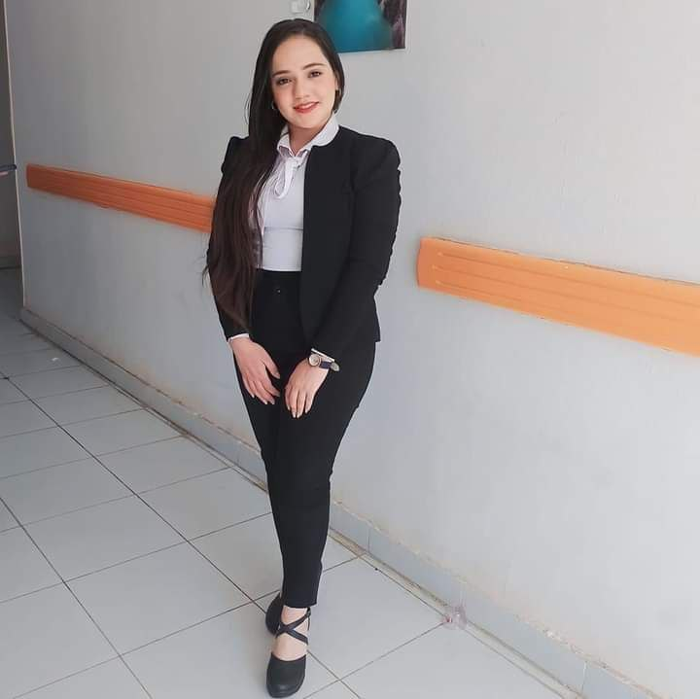
Biography
Samia fathy kamel melk

Department of Pathology & Clinical Pathalogy Faculty of Veterinary Medicine Assuit University.
Personal Data :
Name : Samia fathy kamel melk
Graduation Year : 2023
Study at : Faculty of Veterinary Medicine Assuit University.
Date of birth : 16\9\2000
Phone number : 01278403494
Address : Assuit \ Manfalut
E-mail : samia1@.aun.edu.eg
samiamarina59@gmail.com
# Working as: Demonstrator of Pathology department at Faculty of Veterinary Medicine Assuit
University.

# Teaching to undergraduate students >>>>> practical courses of general pathology, systemic pathology , special pathology & clinical pathology

# Training & courses :
Effective communication skills

The training program of credit hour system

The training course on publishing research in international journals

The training course Foundations of measurement, evaluation and ethics

